**Manual Test Plan**

Steps:

1. Start a new tournament
2. For each endgame in [Forfeit, Checkmate, Stalemate] and for each game type in: [Normal, Weird]:
   1. Start a new game
   2. Play through a game (something from chess.com probably)
   3. Ensure that the game ends in the desired state
      1. It may not be possible to end a weird game in stalemate
   4. Check that game score is stored correctly in tournament view
3. During each of the above game types, test each of the following moves for a variety of pieces. An error should be shown for each of the invalid moves
   1. A valid move
   2. Attempt moving a piece that is not yours
   3. Attempt moving a piece where it cannot move
      1. The piece movement rules restrict it
      2. Moving the piece places you in check
      3. Moving the piece does not take you out of check and needs to
      4. Attempt to make a move from somewhere there is no piece
4. During game play, ensure that all pieces correctly list the locations they can move
5. During game play, try restarting a game and undoing a move

Specific instructions with screenshots:

To start a new chess tournament, open the program and enter both player’s names:

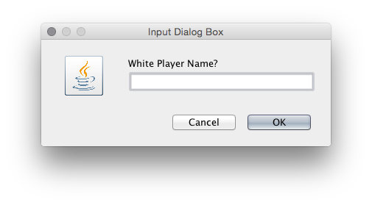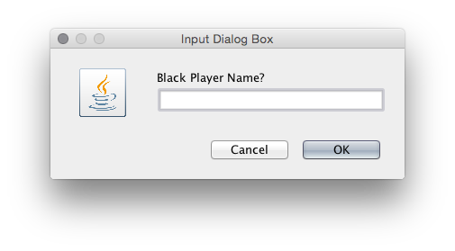

To start a new game, choose a game type, and click “Make new Game”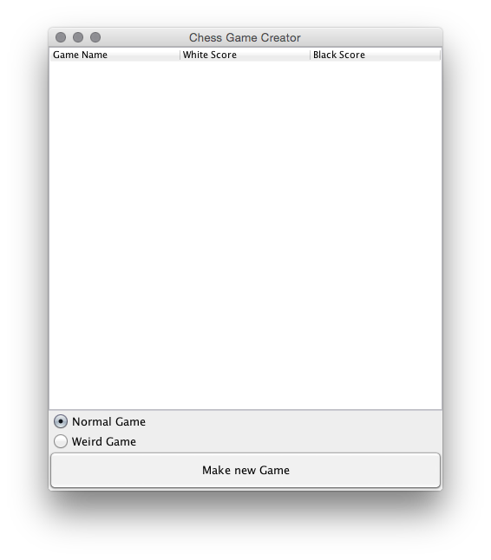

After starting a normal game you should see a screen like this one:

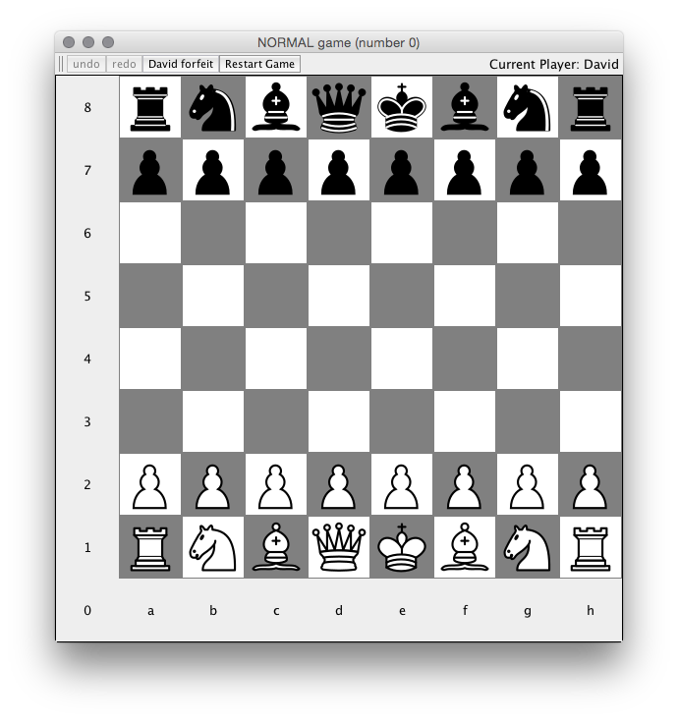

For a weird game:

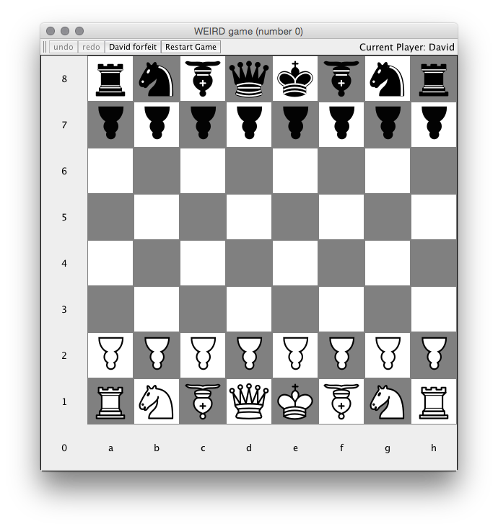

An example error message:

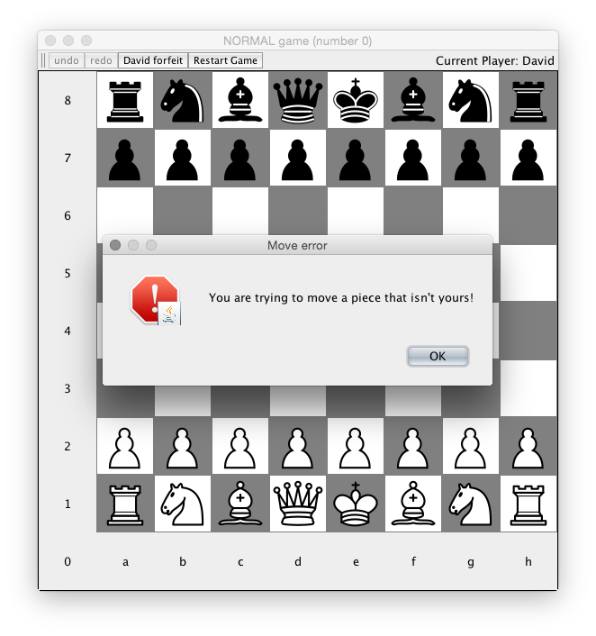

Possible Movement Locations example:

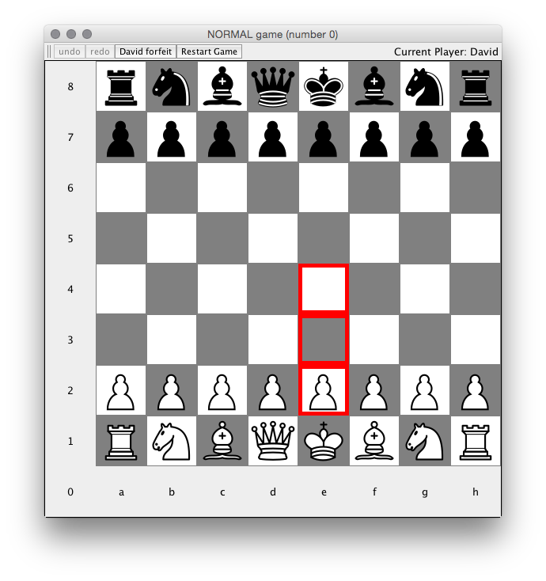

Game Termination Example:

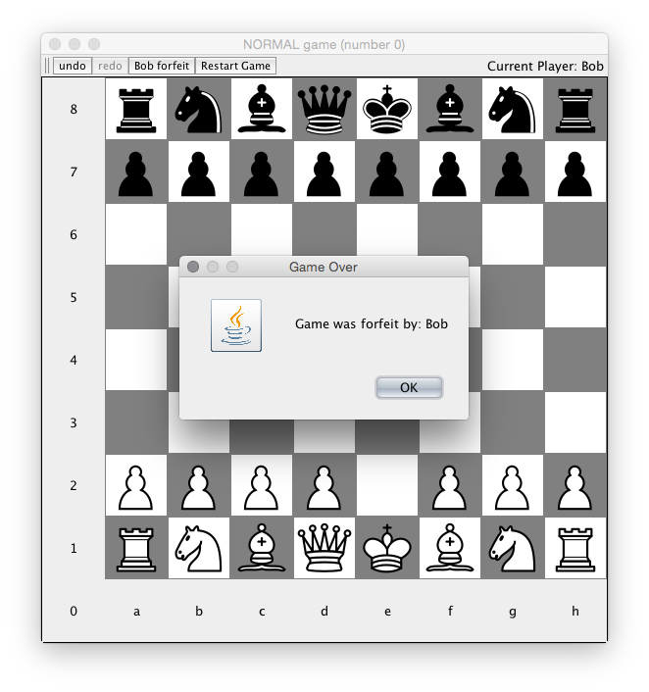

Scores:

